**Question 1)**

public class Parent {  
 public void PMsg(){  
 System.*out*.println("This is parent class");  
 }  
  
 public static void main(String []args){  
 Parent p1 = new Parent();  
 p1.PMsg();  
  
 Child c1 = new Child();  
 c1.CMSg();  
  
 c1.PMsg();  
 }  
}

***output***

for a) b) c)

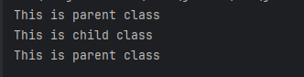

d)

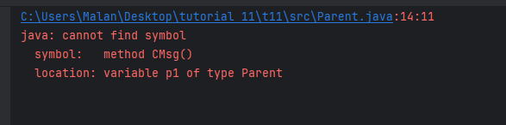

**Question 2)**

public class Member {  
 String Name;  
 int Age;  
 int Phone_Num;  
 String Address;  
 double Salary;  
  
 public void printSalary(){  
 System.*out*.println(this.Name + " Salary is : " + Salary);  
 }  
  
 public static void main(String[] args) {  
 Employee E1 = new Employee();  
 E1.Name="Malan";  
 E1.Age=22;  
 E1.Phone_Num=757292396;  
 E1.Address = "Sandya,thalavitiya,parakaduwa";  
 E1.Salary = 5000.00;  
 E1.specialization = "IT";  
  
 Manager M1 = new Manager();  
 M1.Name="Alwis";  
 M1.Age=25;  
 M1.Phone_Num=780055000;  
 M1.Address = "No.30,jaffna";  
 M1.Salary = 6000.00;  
 M1.department="CS";  
  
 M1.printSalary();  
 E1.printSalary();  
 System.*out*.println();  
 System.*out*.println(E1.Name);  
 System.*out*.println(E1.Age);  
 System.*out*.println(E1.Phone_Num);  
 System.*out*.println(E1.Address);  
 System.*out*.println(E1.Salary);  
 System.*out*.println(E1.specialization);  
 System.*out*.println();  
 System.*out*.println(M1.Name);  
 System.*out*.println(M1.Age);  
 System.*out*.println(M1.Phone_Num);  
 System.*out*.println(M1.Address);  
 System.*out*.println(M1.Salary);  
 System.*out*.println(M1.department);  
 }  
}  
  
class Employee extends Member{  
 String specialization;  
}  
  
class Manager extends Member{  
 String department;  
}

***output***

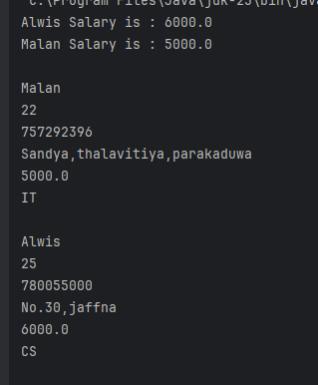

**Question 3)**

public class User {  
 String name;  
 String userID;  
  
 public void login(){  
 System.*out*.println("User " + this.name + " with ID "+ this.userID + " has logged in.");  
 }  
 public static void main(String[] args) {  
 String [] SIn1 = {"Maths","Physics"};  
 Instructor In1 = new Instructor("Malan","EC000",SIn1);  
 String [] SSt1 = {"Maths","IT"};  
 Student St1 = new Student("Alwis","EC012",SSt1);  
 In1.login();  
 St1.login();  
 St1.viewCourses();  
 In1.assignGrades(St1.name,"A");  
  
 }  
}  
  
class Student extends User{  
 String[] enrolledCourses;  
  
 Student(String name,String userID,String [] enrolledCourses){  
 this.name = name;  
 this.userID = userID;  
 this.enrolledCourses = enrolledCourses;  
 }  
  
 public void viewCourses(){  
 System.*out*.print("Enrolled Courses : ");  
 for(int i =0;i<enrolledCourses.length;i++){  
 System.*out*.print(enrolledCourses[i]);  
 if (i<(enrolledCourses.length -1) ){  
 System.*out*.print(", ");  
 }  
 }  
 System.*out*.println();  
 }  
}  
  
class Instructor extends User{  
 String []teachingCourses;  
  
 Instructor(String name,String userID,String [] teachingCourses){  
 this.name = name;  
 this.userID = userID;  
 this.teachingCourses = teachingCourses;  
 }  
  
 public void assignGrades(String StudentName, String grade){  
 System.*out*.println("Instructor "+ this.name +" assigned grade "+  
 grade +" to " + StudentName + " .");  
 }  
  
}

***output***

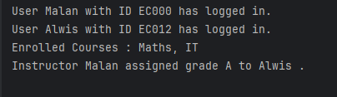

**Question 4)**

***Account.java***

public class Account {  
 String accountNumber;  
 String accountHolderName;  
 double balance;  
  
  
 public double deposit(double amount){  
 balance = amount+balance;  
 System.*out*.println("After Deposit Blance : " + balance);  
 return balance;  
 }  
  
 public void displayAccountDetails(){  
 System.*out*.println("Account Number : " + this.accountNumber);  
 System.*out*.println("Account Holder Name : " + this.accountHolderName);  
 System.*out*.println("Balance : " + this.balance);  
 }  
}  
  
class SavingsAccount extends Account{  
 double interestRate;  
  
 SavingsAccount( String accountNumber,String accountHolderName,double balance,double interestRate){  
 this.accountNumber = accountNumber;  
 this.accountHolderName = accountHolderName;  
 this.balance = balance;  
 this.interestRate = interestRate;  
 }  
  
 public double withdraw(double amount){  
 if(balance>=amount){  
 balance = balance - amount;  
 System.*out*.println("New Balance is : " + balance);  
 }else{  
 balance= balance;  
 System.*out*.println("Balance is insufficient.");  
 }  
 return balance;  
 }  
  
 public double applyInterest(){  
 balance = balance + balance * interestRate/100;  
 System.*out*.println("New Balance after applying Interest : " + balance);  
 return balance;  
 }  
  
}  
  
class CurrentAccount extends Account{  
 double creditLimit;  
  
  
  
 CurrentAccount( String accountNumber,String accountHolderName,double balance){  
 this.accountNumber = accountNumber;  
 this.accountHolderName = accountHolderName;  
 this.balance = balance;  
 }  
 public double setCreditLimit(double limit){  
 this.creditLimit = limit;  
 return this.creditLimit;  
 }  
 public double withdraw(double amount){  
 if(creditLimit>=amount){  
 creditLimit = creditLimit - amount;  
 System.*out*.println("New Credit Limit is : " + creditLimit);  
 }else{  
 creditLimit= creditLimit;  
 System.*out*.println("Credit Limit is insufficient.");  
 }  
 return creditLimit;  
 }  
}

***CreateAccounts.java***

public class CreateAccounts {  
 public static void main(String[] args) {  
 SavingsAccount S1 = new SavingsAccount("2021","Malan",5000,5);  
 CurrentAccount C1 = new CurrentAccount("2022","Alwis",20000);  
 C1.setCreditLimit(5000);  
 System.*out*.println(S1.accountNumber);  
 System.*out*.println(S1.accountHolderName);  
 System.*out*.println(S1.balance);  
 System.*out*.println(S1.interestRate);  
 System.*out*.println();  
 System.*out*.println(C1.accountNumber);  
 System.*out*.println(C1.accountHolderName);  
 System.*out*.println(C1.balance);  
 System.*out*.println(C1.creditLimit);  
 System.*out*.println();  
 S1.deposit(20000);  
 S1.withdraw(30000);  
 S1.withdraw(3000);  
 System.*out*.println();  
 System.*out*.println(S1.accountNumber);  
 System.*out*.println(S1.accountHolderName);  
 System.*out*.println(S1.balance);  
 System.*out*.println(S1.interestRate);  
 System.*out*.println();  
 S1.applyInterest();  
 System.*out*.println();  
 C1.withdraw(6000);  
 C1.withdraw(5000);  
 System.*out*.println();  
 System.*out*.println(C1.accountNumber);  
 System.*out*.println(C1.accountHolderName);  
 System.*out*.println(C1.balance);  
 System.*out*.println(C1.creditLimit);  
  
  
  
  
 }  
}

***output***

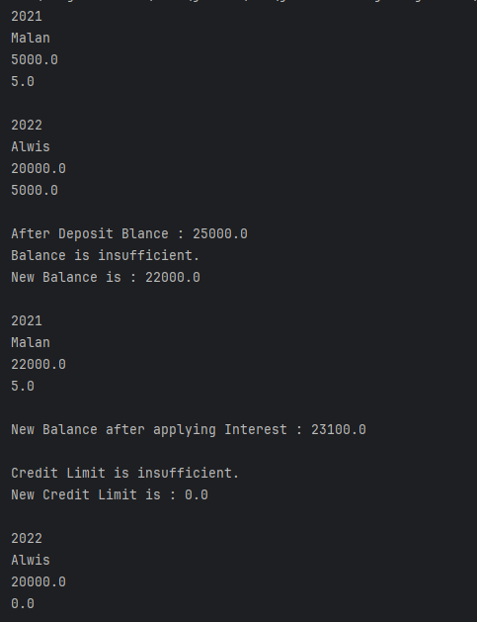

**Question 5)**

public class Cal {  
 int add(int a, int b){  
 return a+b;  
 }  
 double add(double a, double b){  
 return a+b;  
 }  
 int subtract(int a, int b){  
 return a-b;  
 }  
 double subtract(double a, double b){  
 return a-b;  
 }  
 int division(int a, int b){  
 return a/b;  
 }  
 double division(double a, double b){  
 return a/b;  
 }  
  
 public static void main(String[] args) {  
 Cal Cl = new Cal();  
 System.*out*.println("5 + 6 = " + Cl.add(5,6));  
 System.*out*.println("5 + 5.5 = " + Cl.add(5.0,5.5));  
 System.*out*.println("7 - 2 = " + Cl.subtract(7,2));  
 System.*out*.println("5.25 - 0.125 = " + Cl.subtract(5.25,0.125));  
 System.*out*.println("35 / 4 = " + Cl.division(35,4));  
 System.*out*.println("60.5/3.3 = " + Cl.division(60.5,3.3));  
  
 }  
  
}

***output***

**Question 6)**

public class StringManipulator {  
 String reverse(String s){  
 String r="";  
 char ch;  
 for(int i=0;i<s.length();i++) {  
 ch = s.charAt(i);  
 r = ch + r;  
 }  
 return r;  
 }  
  
 String reverse(String s, int n){  
 String r="";  
 char ch;  
 for(int i=0;i<n;i++) {  
 ch = s.charAt(i);  
 r = ch + r;  
 }  
 return r;  
 }  
 String reverse(String s,int start,int end){  
 String r="";  
 char ch;  
 for(int i=start-1;i<=end-1;i++) {  
 ch = s.charAt(i);  
 r = ch + r;  
 }  
 return r;  
 }  
  
 public static void main(String[] args) {  
 StringManipulator S1 = new StringManipulator();  
 System.*out*.println(S1.reverse("12345678"));  
 System.*out*.println(S1.reverse("12345678",4));  
 System.*out*.println(S1.reverse("12345678",2,5));  
 }  
  
}

***output***

